**Pembuatan Aplikasi E-Voting Berbasis Web**

1Muhammad Izad Airizam, 2Nasywa Nur Azizah

Kelas XII (Rekayasa Perangkat Lunak)  
SMK Bina Mandiri Multimedia

[email](mailto:muhammadsai@uinmataram.ac.id): [izadairizam06@gmail.com](mailto:izadairizam06@gmail.com) , [nasywaazizah1807@gmail.com](mailto:nasywaazizah1807@gmail.com)

**INTRODUCTION**

E-voting comes from the word electronic voting which refers to the use of information technology in the implementation of voting. No less important is how the voting process can guarantee the principle of direct, general, free and secrets as well as how the results of the vote count can be carried out honestly, transparent, accessible to the public. During this time, voting carried out by ticking or voting on the ballot paper as an option in election administration. In the process of selecting the chairman of the Intra-School Student Organization (OSIS) most of them are still done manually, this is considered less effective with the development of technology

By leveraging existing technology this website-based E-Voting application can make activities the election of the student council president is easy to convey information, faster in calculating votes, and making it more efficient on paper so that the results obtained can be effective and efficient.

This is very important because with this application, no more lack of information, wasted paper and can count the results of the vote quickly and will make it easier for students and teachers who oversee the election of the student council president the. With the development of e-voting technology, it has a security and public trust is a crucial thing that needs to be considered in holding general elections. Like data manipulation, vote acquisition, so that integrity in the implementation of elections is far from direct, general, free and confidential principles.

So, from the explanation above, it can be concluded that E-Voting is a voting that conducted electronically (digitally) starting from the voter registration process, conduct of elections, counting of votes and sending of vote results.

**METODE**

* Tools and Materials

The tools used in this research are include:

1. Acer Aspire f5-672g
2. Processor intel(R) core(tm) i3-6006U cpu@ 2.00Ghz 4(CPUs),2.0GHz
3. XAMPP
4. PHP
5. Sublime Text
6. Browser Google

* User Interface Design

1. Main menu design

The main menu is a display that displays start page on application when logging in from from login, from the main menu there are features that can be selected by the user at the time of logging in the main display will display Selection page in this view the user can directly choose the desired candidate pair, page the homepage contains information about the set students, display candidate data where users can see the vision, mission and goals of the candidate to become a candidate, the progressbar page displays the user interface poll result percentage

1. Voting Menu Design

This menu is designed so that users can use the right to vote to choose a candidate pair want to be selected, when the user has made a choice the village candidate pair then click the save button then it will save and cannot be thwarted.

1. Login Menu Design

In the login view used by the user and admin so that users and admins or users can log in to the page that has been set from the voting web application, in this page the user or the user is requested enter username and password. After username and the password has been inputted the user can press the button or login button to start entering page view main of voting application. when the username presses button or login button before inputting it then will still be on the login page

1. Candidate Data Menu Design

This Candidate Data menu will display the vision and the mission of the candidate pair with this menu user can find out the candidate pairs to be selected from description of the work program.

*Flowchart Login*

No

Yes

No

Yes

**Start**

**Halaman utama**

**Login**

Username& Password

Validate

**Dashboard**

**Pasangan Calon**

Validate

Data Pasangan calon

**Finish**

**RESULT**

1. Login Display

In this form admin and user can login according to the username and password that has been created

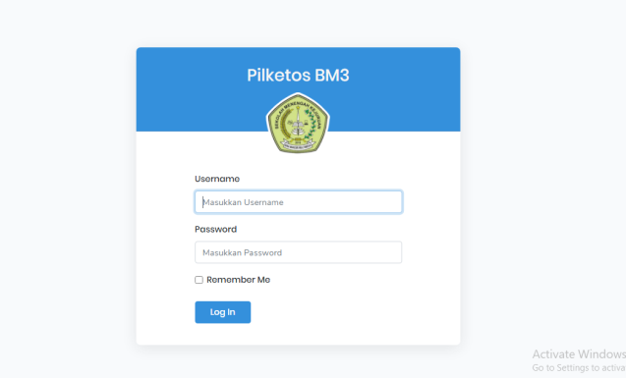

Gambar 3.1 Login Display

1. Dashboard View

In this Dashboard view, the admin is used to add candidate pairs, edit and delete them

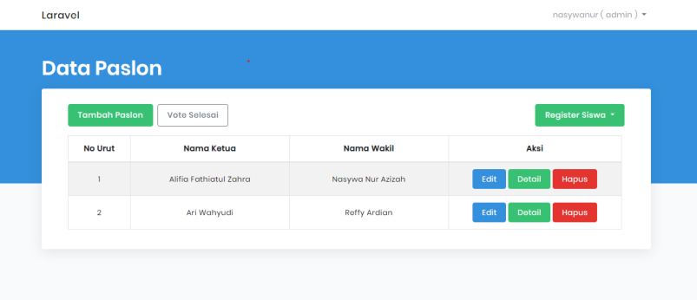

Gambar 3.2 Dashboard View

1. Home View

This view can be accessed by users who already have an account, and users can directly vote after seeing the vision and mission on the candidate pair form.

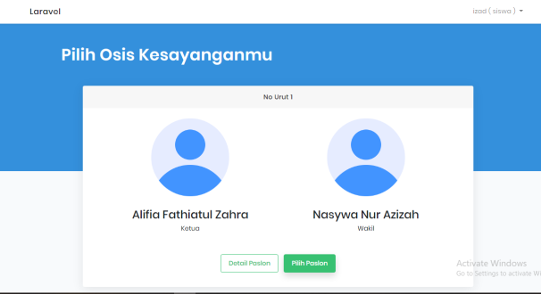

Gambar 3.3 Home View

* Obstacles and problems

1. difficulty in finding the right design
2. difficulty in matching display colors
3. difficult to determine project flow

**CONCLUSION**

* KESIMPULAN

Based on the results of research and analysis that has been carried out, the following conclusions have been obtained:

1. From the results of research conducted, there are achievements build e-Voting applications with implementers from the achievement of science in the lectures that have been obtained, this system is useful for choosing a partner candidate for the Chair of the OSIS.
2. The e-Voting system application can make it easier students in choosing a candidate pair for OSIS Chair, choose online without having to use the method conventional that has been done so far.

* SARAN

Here are suggestions for apps are as follows:

1. In future research, it is hoped that the eVoting application for the election of the OSIS Chairperson, implemented with android technology.
2. In the e-Voting System, it is hoped that in the future able to create a time timer so that every user who haven't chosen can't choose because of the time determined to have expired.
3. This e-Voting system is also expected in the future have the number of votes displayed on e-Voting application.

**REFERENCES**

Wikipedia (<https://id.m.wikipedia.org/wiki/Pemungutan_suara_elektroniK> )

PDF (<https://media.neliti.com/media/publications/338578-perancangan-sistem-e-voting-berbasis-weba8dbfbb8.pdf> )